On-board, Real-Time, FIRST Robot Current Monitor

Overview
This paper describes a method of monitoring the current used by a FIRST Robot (http://www.usfirst.org) during normal operation. The current utilization information is provided to the Robot Controller in the form of an analog input. Cables, connectors, and enclosure excluded, the design uses a single component which costs under $20.00. The system measures current from 0 to 240 Amperes in approximately 2.34 Ampere (Amp) increments.

Why monitor current?
Monitoring the level of current consumption in your Robot can be useful. The main breaker in the Robot is rated at 60 Amps. If you greatly exceed the 60 Amp limit during a match, you run the risk of tripping the breaker stopping your Robot dead in its tracks. One set of test data for the 60 Amp breaker indicates it will trip after 8 seconds under a 200 Amp load and after 108 seconds with a 100 Amp load. If you have the ability to constantly monitor the current used by the Robot, your software can scale back current consumption or provide a warning when you are in danger of tripping the main breaker.

Hall Effect Current Transducer
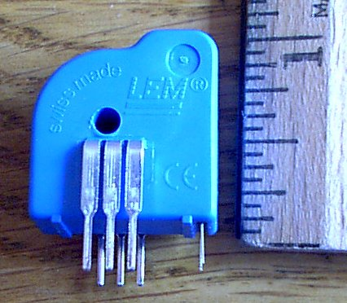
In the Digi-Key (http://www.digi-key.com) catalog (page 852 of the Jan-Apr 2002 edition), there are a series of “Closed Loop Current Transducers” manufactured by LEM (http://www.lemusa.com). These transducers use the Hall Effect to monitor current. Hall Effect sensors have significant advantages over the use of a shunt resistor, another method for measuring current. We will use the LEM LTS 25-NP transducer. This transducer can measure up to 80 Amps, uses a single + 5 Volt Direct Current (VDC) power supply, and outputs an analog voltage in the .5 Volt (one half) to 4.5 Volt range centered at 2.5 Volts. The single quantity price of the transducer is less than $20.00.

Using a Current Divider
Since the current measurement range of interest is larger than the 80-Ampere range of the transducer, we use a current divider to scale down the current and then measure the current in the scaled portion of the circuit. A well-known corollary of Ohm’s law is if an electrical current is presented with several paths of equal resistance, the current will divide itself equally between the paths. Another fact is the resistance of a uniform piece of wire is proportional to its length. If we take a piece of wire and cut it into pieces of equal length, then each piece will have approximately the same resistance.

In order to build a current divider, take a length of black #10 AWG wire and cut it into 3 pieces exactly six inches long. Strip a three-inch piece of insulation from one of the wires. All other ends of the wires are stripped back one half inch. The six-inch length is not critical and longer or shorter equal lengths of wire could be used. Longer pieces are likely to more evenly divide the current, but have a slightly larger voltage drop. Shorter pieces might be less even dividers, but have a lower voltage drop.

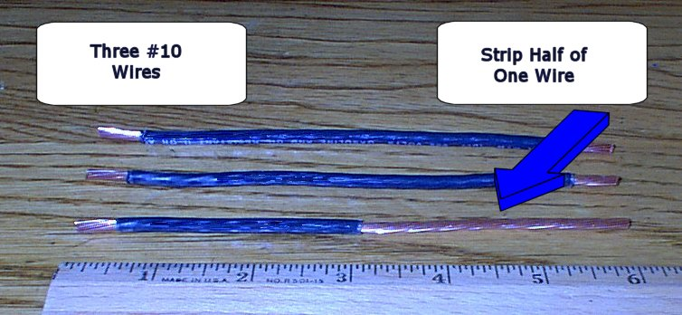

Preparing the Hall Effect transducer
If you examine the transducer, you will notice there is a hole that goes through the center. If a wire is threaded through the hole, the transducer will monitor the current flow in the wire. Take the #10 wire with 3 inches of insulation removed and thread the bare portion of the wire through the hole in the transducer. When the transducer is in place pushed against the remaining insulation, place heatshrink tubing over the bare wire leaving one half inch bare at the end. Shrink the tubing down onto the bare wire. The insulation has been removed simply to get the wire to physically fit through the hole and not in order to make electrical contact with the transducer.

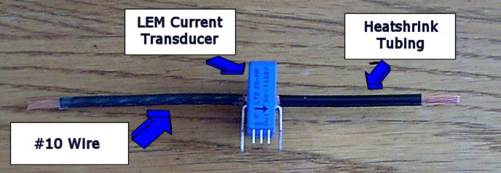

If you examine the above figure, you can also see a tiny arrow printed on the visible side of the transducer. When the transducer is in the circuit, the arrow should electrically “point” to the negative terminal of the battery.

Preparing the Anderson Power Connector
An Anderson power connector is prepared by attaching a ring terminal to the #6 AWG black wire. The black wire is then cut in the middle and the two cut ends stripped back one half inch.

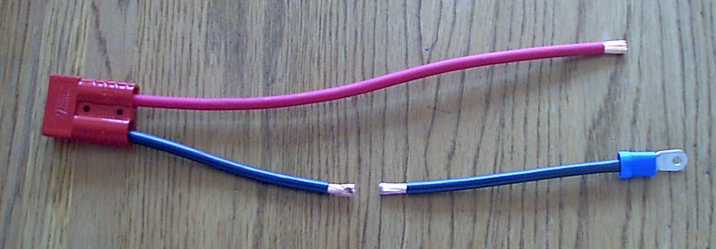

Constructing the Monitor
Place one end of each of the three, six inch, #10 wires, (one with the transducer in the middle) into one side of a wire splice. Ilsco SPA-2 splices are good, but any appropriately sized splice could be used. The ends of the wire should be lined up and the screw tightened down on the wires. Next, the section of #6 black wire from the Anderson connector with the ring terminal is added to the other end of the splice. See the figure, which follows. The arrow on the transducer should be pointing away from the ring terminal.

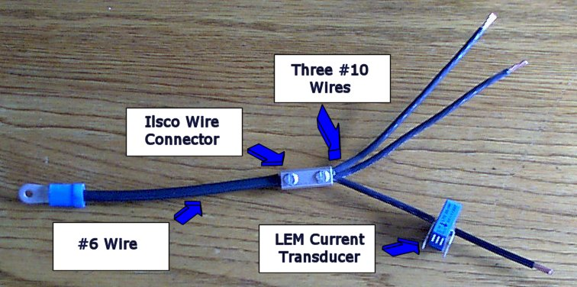

A second splice is used to connect the free ends of the three #10 wires. Next the stripped end of the black #6 wire still attached to the Anderson connector is added to the other side of the splice.

Connecting the Transducer to the Robot Controller
The transducer has two sets of three larger pins. There are three smaller pins along one edge of the transducer. The six larger pins are not used and should be covered with electrical tape to keep them from accidentally shorting to another part of the robot. The smaller pins are used to connect the transducer to the Robot Controller. The three pins are +5 VDC, ground, and Out (labeled +, 0, and Out respectively). The transducer is wired to Analog/Sensor Input #1 using the following connection.

Transducer Pin | Analog Input Pin | Description
+ | 1 | +5 VDC for “Gyro”*
0 | 4 | Ground
Out | 2 | Analog/Sensor #1 Input

*Note: The +5 VDC pins on the analog connector have an internal 100 ohm series resistor and do not provide sufficient drive to power the current transducer, so the +5 VDC pin for “Gyro” power is used.

In order to make this connection, use a length of two pair cable long enough to reach from the current monitor to the analog input of the Robot Controller. It will make your job easier if you use a cable with uniquely colored wires. The two pair cable used to hook up telephones works well. Use one of the pair for the “+5 VDC” and “ground” connection and one of wires in the remaining pair for the “Out” connection. The fourth wire is not used. Strip a small section of insulation from the wire and carefully solder a wire directly to each of the three pins on the transducer. Before soldering the wires, slide a piece of heatshrink tubing down over each wire well past the stripped section. Once the three wires are soldered to the transducer, slide the heatshrink back up over the soldered connection and shrink the tubing down over each bare wire/pin. The other ends of the wires are either crimped or soldered to the 25-pin male connector which mates to the Robot Controller Analog Input according to the pin assignment table above.

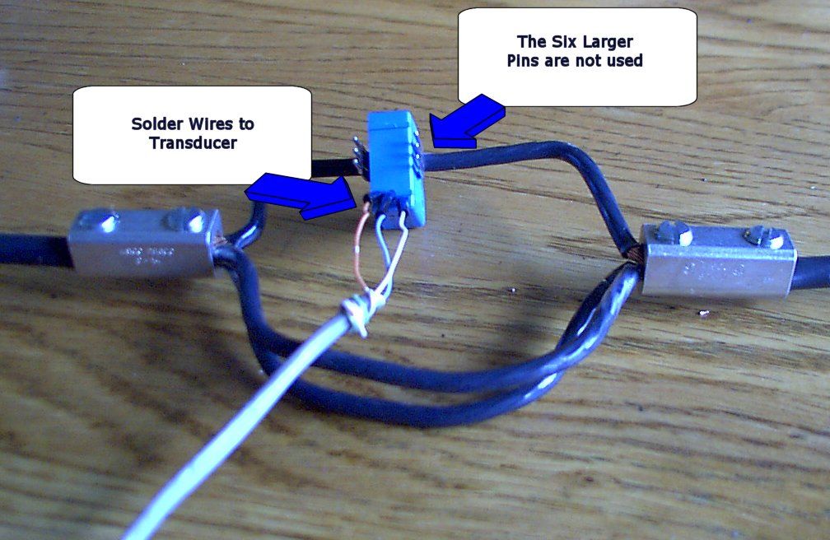

Connecting the Current Monitor to the Robot

Important Note: Wiring to the Robot power circuits must be done with the battery disconnected. If you are not familiar with power wiring and appropriate safety measures, please work with someone on your team who is.

The connection of the Current Monitor to the Robot is straightforward. If there is an existing Anderson power cable between the Battery and the Robot, remove it and replace it with the current monitor/cable assembly. Otherwise, the assembly is installed like the regular Anderson connector. See the figure, which follows, for more detail on the installation.

Routing of the Wires
Since the Hall Effect transducer reacts to the magnetic field in a wire, be careful in the routing of wires. The transducer should not be placed close to motors, solenoids, or other power wires. The wire being measured should go straight in one side of and out the other and not wrap back around the transducer. Use a plastic cable tie to help hold the transducer in place on the #10 wire.

Enclosure for the Transducer
In the 2002 FIRST competition, the contest rules allow for a “custom circuit” in the Robot. Any custom circuit must be enclosed in a Bud Industries plastic enclosure part number PN-1324-C. To mount the transducer in the Bud enclosure cut two slots in the lower part of the enclosure just large enough for the #6 wires and a slot for the cable to the Analog input. The lid of the enclosure will hold the assembly in place. Make sure the transducer and its #10 wire is physically separate from the other two #10 wires in the current divider. Wrap electrical tape around the wire splices to prevent them from accidentally shorting to the Robot.

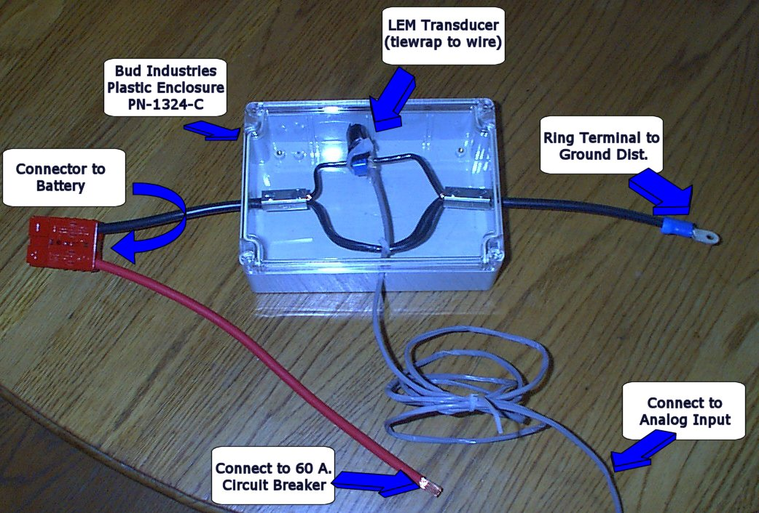

Test It
Power up the Robot and read the value being returned by Sensor Input #1 with the motors and solenoids turned off. Its value should be right around 127 which is the middle of the Analog input range and the zero current value. The actual current is somewhat above zero as the Robot Controller, transducer, and other electronics in the Robot are active. As motors turn on and solenoids are activated, the values returned by the Analog input should increase. Each single step above the zero current value represents an increase of approximately 2.34 Amps. A table at the end of this document gives the corresponding current for each of the returned values.

Explanation of the Current Calculation
The current divider splits the current in the Robot into three equal parts. The transducer measures the current in one part, so the current measured represents one-third the total current in the Robot. The transducer current times three will be the total current in the Robot. When the current in the Robot is zero, the transducer voltage is at the midpoint of the output range or 2.5 VDC. When the current in the Robot is 240 Amperes, the transducer will output the maximum of its range or +4.5 VDC. The transducer can also measure “negative” current, but because of the configuration of the circuit, the current should always be zero or higher. The Analog Input divides the range from +2.5 VDC to +5 VDC into 128 “steps”. As the maximum output of the transducer is 4.5 VDC, the number of usable steps is ( ²/_{2.5}* 128) = ~102. The current range being measured is 240 Amperes so each step is 240/102.4 = 2.34375 Amperes. If the voltage output from the transducer drops below 2.5 Volts and the Analog Input value goes below 127 as current flows in the Robot, you have likely installed the sensor backwards. Check to make sure the arrow on the transducer is electrically pointing towards the negative terminal of the battery.

Check Accuracy
A good way to test the monitor’s accuracy is to use a current meter to make measurements in parallel with the on-board monitor. A Hall Effect clamp-on attachment for a multi-meter is probably the easiest way to take a side-by-side current reading. Your clamp-on must be rated for direct current (DC).

Weight
The unit weighs about 14 ounces, which is mostly the 10.2 ounces of the BUD enclosure. This figure excludes the weight of the Anderson power connector, which is required on the robot.

Current Consumption
The transducer uses less than 65 mA under worst case conditions.

Copyright
This document is copyright © 2002 Steve Bunning. Permission is granted to freely use, copy, and distribute this document as long as the copyright information is maintained and the document is not modified.

Let Me Hear about your Experience
I’d love to hear about your experience with current monitoring. Send me an email and let me know how it worked for you. Good luck in the FIRST competition.

Steve Bunning (bunning@mildlyeccentric.com)
Mentor for Team #620, James Madison High School
Fairfax, VA
Chart of Sensor Input -Voltage - Current

Sensor Input | Voltage | Current |  | Sensor Input | Voltage | Current |  | Sensor Input | Voltage | Current
127 | 2.500 | 0.0 |  | 162 | 3.184 | 82.0 |  | 197 | 3.867 | 164.1
128 | 2.520 | 2.3 |  | 163 | 3.203 | 84.4 |  | 198 | 3.887 | 166.4
129 | 2.539 | 4.7 |  | 164 | 3.223 | 86.7 |  | 199 | 3.906 | 168.8
130 | 2.559 | 7.0 |  | 165 | 3.242 | 89.1 |  | 200 | 3.926 | 171.1
131 | 2.578 | 9.4 |  | 166 | 3.262 | 91.4 |  | 201 | 3.945 | 173.4
132 | 2.598 | 11.7 |  | 167 | 3.281 | 93.8 |  | 202 | 3.965 | 175.8
133 | 2.617 | 14.1 |  | 168 | 3.301 | 96.1 |  | 203 | 3.984 | 178.1
134 | 2.637 | 16.4 |  | 169 | 3.320 | 98.4 |  | 204 | 4.004 | 180.5
135 | 2.656 | 18.8 |  | 170 | 3.340 | 100.8 |  | 205 | 4.023 | 182.8
136 | 2.676 | 21.1 |  | 171 | 3.359 | 103.1 |  | 206 | 4.043 | 185.2
137 | 2.695 | 23.4 |  | 172 | 3.379 | 105.5 |  | 207 | 4.063 | 187.5
138 | 2.715 | 25.8 |  | 173 | 3.398 | 107.8 |  | 208 | 4.082 | 189.8
139 | 2.734 | 28.1 |  | 174 | 3.418 | 110.2 |  | 209 | 4.102 | 192.2
140 | 2.754 | 30.5 |  | 175 | 3.438 | 112.5 |  | 210 | 4.121 | 194.5
141 | 2.773 | 32.8 |  | 176 | 3.457 | 114.8 |  | 211 | 4.141 | 196.9
142 | 2.793 | 35.2 |  | 177 | 3.477 | 117.2 |  | 212 | 4.160 | 199.2
143 | 2.813 | 37.5 |  | 178 | 3.496 | 119.5 |  | 213 | 4.180 | 201.6
144 | 2.832 | 39.8 |  | 179 | 3.516 | 121.9 |  | 214 | 4.199 | 203.9
145 | 2.852 | 42.2 |  | 180 | 3.535 | 124.2 |  | 215 | 4.219 | 206.3
146 | 2.871 | 44.5 |  | 181 | 3.555 | 126.6 |  | 216 | 4.238 | 208.6
147 | 2.891 | 46.9 |  | 182 | 3.574 | 128.9 |  | 217 | 4.258 | 210.9
148 | 2.910 | 49.2 |  | 183 | 3.594 | 131.3 |  | 218 | 4.277 | 213.3
149 | 2.930 | 51.6 |  | 184 | 3.613 | 133.6 |  | 219 | 4.297 | 215.6
150 | 2.949 | 53.9 |  | 185 | 3.633 | 135.9 |  | 220 | 4.316 | 218.0
151 | 2.969 | 56.3 |  | 186 | 3.652 | 138.3 |  | 221 | 4.336 | 220.3
152 | 2.988 | 58.6 |  | 187 | 3.672 | 140.6 |  | 222 | 4.355 | 222.7
153 | 3.008 | 60.9 |  | 188 | 3.691 | 143.0 |  | 223 | 4.375 | 225.0
154 | 3.027 | 63.3 |  | 189 | 3.711 | 145.3 |  | 224 | 4.395 | 227.3
155 | 3.047 | 65.6 |  | 190 | 3.730 | 147.7 |  | 225 | 4.414 | 229.7
156 | 3.066 | 68.0 |  | 191 | 3.750 | 150.0 |  | 226 | 4.434 | 232.0
157 | 3.086 | 70.3 |  | 192 | 3.770 | 152.3 |  | 227 | 4.453 | 234.4
158 | 3.105 | 72.7 |  | 193 | 3.789 | 154.7 |  | 228 | 4.473 | 236.7
159 | 3.125 | 75.0 |  | 194 | 3.809 | 157.0 |  | 229 | 4.492 | 239.1
160 | 3.145 | 77.3 |  | 195 | 3.828 | 159.4 |  | 230 | 4.512 | 240.0
161 | 3.164 | 79.7 |  | 196 | 3.848 | 161.7

Values between 0-126 and values over 230 should not occur during normal operation.

